***Temperature And Humidity Detector***

**Introduction:**

This project is all about measuring the environmental changes and Display as Digital signals Through many components in simulide. Temperature and humidity sensor is device that can convert temperature and humidity into electrical signals that can easily measure temperature and humidity.

**DHT11 sensor:**

* DHT11 is a single wire digital humidity and temperature sensor, which provides humidity and temperature values serially.
* It can measure the relative humidity in percentage (20 to 90% RH) and temperature in degree Celsius in the range of 0 to 50°C.
* It has 4 pins of which 2 pins are used for supply, 1 is not used and the last one is used for data.
* The data is the only pin used for communication. Pulses of different TON and TOFF are decoded as logic 1 or logic 0 or start pulse or end of the frame.
* For more information about the DHT11 sensor and how to use it, refer to the topic [DHT11 sensor](http://electronicwings.com/sensors-modules/dht11) in the sensors and modules topic.

**HD44780-1:**

The Hitachi HD44780 LCD controller is limited to monochrome text displays and is often used in [copiers](https://en.wikipedia.org/wiki/Copier), [fax machines](https://en.wikipedia.org/wiki/Fax_machine), [laser printers](https://en.wikipedia.org/wiki/Laser_printer), industrial test equipment, and networking equipment, such as [routers](https://en.wikipedia.org/wiki/Router_(computing)) and [storage devices](https://en.wikipedia.org/wiki/Object_storage_device).

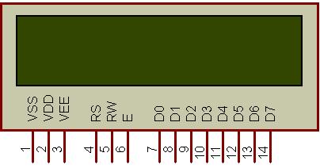

Compatible LCD screens are manufactured in several standard configurations. Common sizes are one row of eight characters (8×1), and 16×2, 20×2 and 20×4 formats. Larger custom sizes are made with 32, 40 and 80 characters and with 1, 2, 4 or 8 lines. The most commonly manufactured larger configuration is 40×4 characters, which requires two individually addressable HD44780 controllers with expansion chips as a single HD44780 chip can only address up to 80 characters.

**Programming of DHT11:**

* First, initialize the LCD16x2_4bit library.
* Define pin no. to interface DHT11 sensor, in our program we define PD6 (Pin no. 20).
* Send the start pulse to the DHT11 sensor, making low to high.
* Receive the response pulse from the DHT11 sensor.
* After receiving the response, receive 40-bit data serially from the DHT11 sensor.
* Display this received data on LCD16x2 along with error indication.

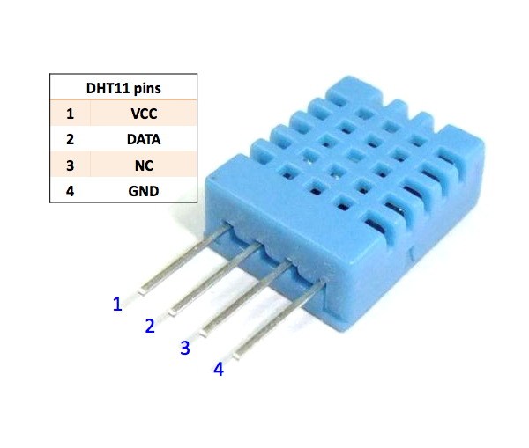

**Breif Description About Project:**

The components of the temperature and humidity sensor module mainly include a humidity sensitive capacitor and a conversion circuit. The humidity sensitive capacitor is composed of a glass substrate, a lower electrode, a humidity sensitive material, and an upper electrode. Humidity sensitive material is a kind of high molecular polymer, its dielectric constant changes with the relative humidity of the environment. When the environmental humidity changes, the capacitance of the humidity sensitive element changes accordingly. That is, when the relative humidity increases, the humidity sensitive capacitance also increases, and vice versa. The conversion circuit of the sensor converts the change in humidity-sensitive capacitance into a change in voltage, which corresponds to a change in relative humidity of 0 to 100% RH. The output of the sensor shows a linear change of 0 to 1v.

Temperature and humidity sensors are among the most commonly used [environmental sensors](https://www.comptus.com/). Humidity sensors are also sometimes referred to as hygrometers. These devices are used to provide the actual humidity condition within the air at any given point or in any given place. Such devices are commonly used in situations in which air conditions may be extreme or where air conditions need to be controlled due to varying reasons.

Humidity is the presence of water within the air. The amount of water vapor that is present in the air can affect not only personal comfort but can also affect various manufacturing processes within industrial applications. For instance, in the semiconductor industry, moisture or humidity levels must be properly controlled and monitored to ensure proper wafer processing. Humidity control is also frequently important for incubators, respiratory equipment, sterilizers, and biological products. In addition, the presence of water vapor may also influence various other chemical, biological, and physical processes.

Measuring humidity within the environment can be critical due to the fact that the higher the humidity, the warmer it may seem. In industries, humidity measurement is often important because it can affect the health and safety of personnel as well as the cost of the product. As a result, temperature and humidity sensors are often quite important.

The measurement of humidity is also an important element of weather reports because the presence of humidity indicates the chance of dew, fog, or precipitation. Higher relative humidity reduces the effectiveness of sweating in order to cool the body. This occurs because evaporation of perspiration from the skin is prevented. This effect is measured in a heat index table. As a result, it may often feel hotter during the summer in areas where there is higher relative humidity.